**Java**

* **Sec 1: Introduction to Java**

Java: Object oriented programming language

Types of programming languages:

1. Structured: C, Python.
2. Object based: VB, VBScript, Python.
3. Object oriented: C++, Java, C#, Python.

OOPS:

1. Class
2. Object
3. Polymorphism
4. Inheritance
5. Abstraction
6. Encapsulation

Features:

1. Platform Independent
2. Case sensitive

3 Components:

1. JDK: Java Development Kit
2. JRE: Java Runtime Environment
3. JVM: Java Virtual machine

Environment setup:

1. JDK/java
2. IDE (Eclipse, IntelliJIDE, etc)

Versions:

1. Java 8: Sun microsystem
2. Java 9: Oracle

Java 11+ preferable

Steps:

1. Create a new java project
2. Create a new java package
3. Create a new class

Class naming conventions:

1. Class name should start with Uppercase
2. Class name should not start with number
3. Class name contains _ (Underscore)
4. Special characters are not allowed
5. Class name contains numbers

* **Sec 2: Java Variables and Data Types**

Variables & Data types:

Variables is a container which can hold data. To represent data we need variables.

int x=100

float itemprice=10.25

int age =30

String name=”John”

char grad=’A’

Data Types:

Represents type of data

1. Premitive:
2. byte, short, int, long: number without decimal
3. float, double: decimal number
4. char: single character (single quote)
5. boolean: true/false
6. Non-premitive/derived/collections:
7. String
8. ArrayList
9. HashMap
10. HashSet

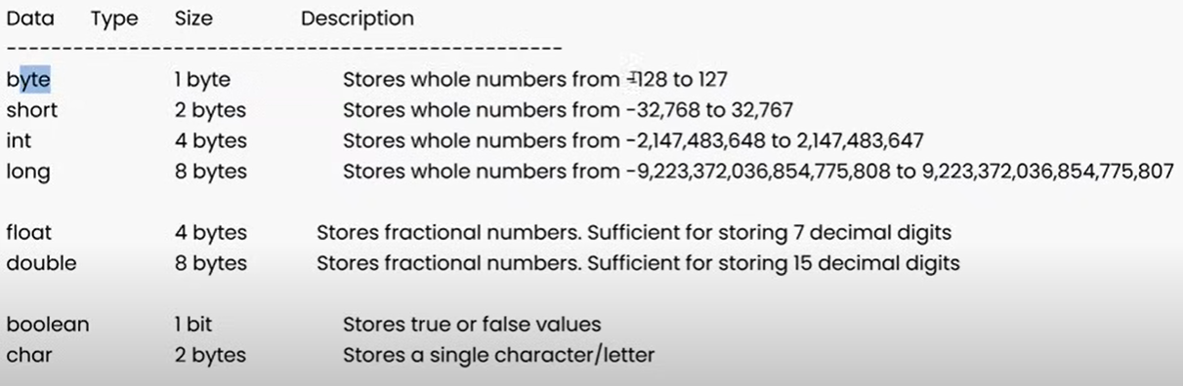

Java is a statically typed programming language

Python is a dynamically typed programming language

* **Sec 3: Java Operators and Expressions:**

Operators:

1. Arithmetic operators

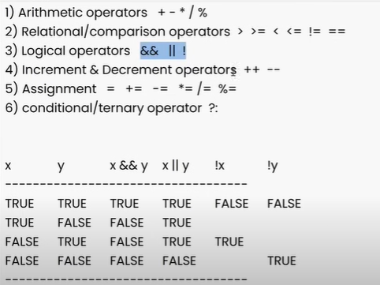

**Selenium WebDriver**

**Sec 21: Selenium Introduction & Environment Setup**

Selenium WebDriver

* What is Selenium WebDriver?

1. WebDriver is one of the components in selenium
2. WebDriver is a java interface
3. WebDriver is an API (Application Programming Interface)

* WebDriver (Interface: I) – RemoteWebDriver (Compiler: C) -> ChromeDriver, FirefoxDriver, EdgeDriver, etc.
* Environment setup:

1. Download jar files and attaching them to Java project (Manually).
2. Create new java project.
3. Download webdriver jars(.zip) and extracted.
4. Attach jars to java project.
5. Create Maven project.
6. Create a new Maven project in eclipse.
7. Add webdriver dependency in pom.xml -> update.

Stable: 4.18.1 (February 19, 2024).

pom.xml ----🡪dependencies <https://mvnrepository.com/>

**Sec 22: Selenium Locators**

Locators:

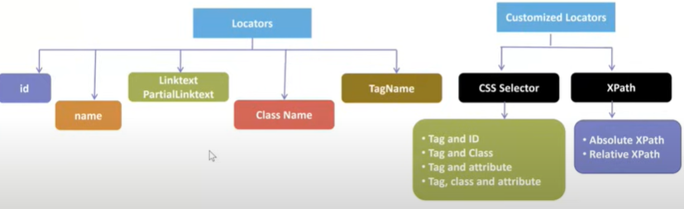

Link Text is preferred over partial link text for identifying/locating element.

Ex: 1) Tablets Table – linkText()

1. Submit Send – partialLinkText()

Locators:

1. Id
2. Name
3. linkText
4. partialLinkText
5. TagName: used for group of webelements
6. Class: used for group of webelements

* findElement() ---- single webelement
* findElements() ---- multiple webelements

Scenario 1: Locator matching with single web element

* findElement(loc) --🡪 single web element: Return Type: WebElement
* findElements(loc) -🡪 single web element: Return Type: List<WebElement>

Scenario 2: Locator matching with multiple web element

* findElement(loc) --🡪 single web element: Return Type: WebElement
* findElements(loc) -🡪 multiple web element: Return Type: List<WebElement>

Scenario 3: Locator is not matching with any element/s

* findElement(loc) --🡪 Exception Returned: No Such Element Exception.
* findElements(loc) -🡪 Will not throw any Exception. Returns 0.

**Sec 30: Selenium Handling Frames/iFrames & Nested iFrames**

frames/iframes

id/name/webelement

driver.SwitchTo().frome()

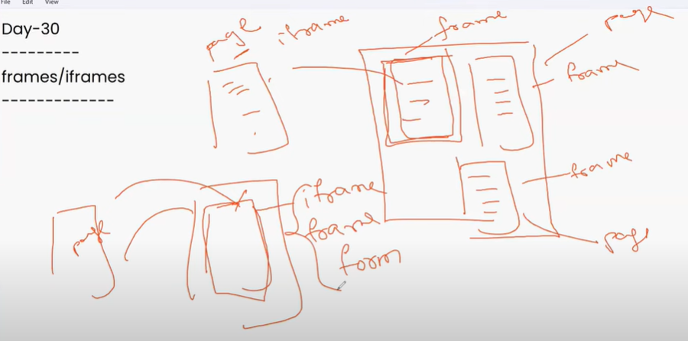

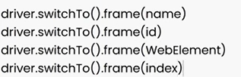

**Sec 31: Selenium Handling Dropdows**

* Dropdown box:

1. Select dropdown
2. Bootstrap dropdown
3. Hidden dropdown

* Select Dropdown

Select:

1. selectByVisibleText() : visible text means visible value of text.
2. selectByvalue() : means attribute value
3. selectByIndex()

Ex:

WebElement drpCountryEle = driver.findElement(By.*xpath*("//select[@id='country']"));

Select drpCountry = **new** Select(drpCountryEle);

* getOptions() : returns all the options from the dropdown as a WebElement.
* Bootstrap dropdown
* .